https://nrich.maths.org/88
Challenge Level
Patterns/shape

Sticky Triangles
I was exploring a puzzle in which headless match sticks had to be moved to make a different number of triangles.
I made one small triangle
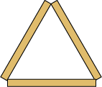 | 3 ma

I made it into 4 small triangles by adding 6 matches.
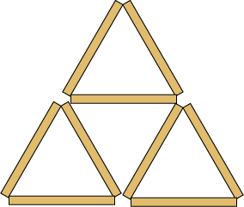 | 9 mat
I added another row and counted the number of small triangles and counted the matches.
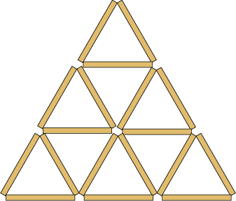

I made a table of my results and continued adding rows. I found many patterns.

Have a go and see what patterns you can find. You do not have to use match sticks (or cocktail sticks) - drawing lines will do just as well.
Find a good way to record your results. See if you can predict the numbers for rows of triangles you have not drawn.
When you have done all you can with triangles, see if you get the same sort of results with squares. Then think of other shapes which might make number patterns as they grow.

https://nrich.maths.org/2105
Challenge Level
Fractions

Light Blue - Dark Blue

Stage: 2

Investigate the successive areas of light blue.
What fraction of the total area of the square does the area of light blue take up in each case?
Can you work out what the next two diagrams would look like?

http://nrich.maths.org/136
Number
Challenge Level (Low floor, high ceiling)

The Cycling Shop

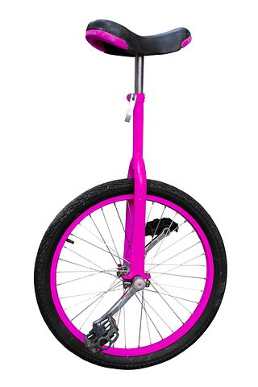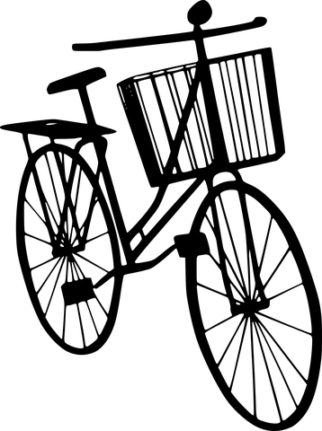

Imagine you work at a cycling shop building unicycles, bicycles and tricycles for customers. One day, you receive a shipment of 8 wheels. Presuming that each cycle uses the same type and size of wheel, what are all the combinations of cycles you can make using all 8 wheels.

How many different answers can you find?
Can you explain how you found out these answers?

Extension: You have a shipment of 12 wheels, how many different combinations can you make now?

http://nrich.maths.org/8315
Challenge Level
Number/Operations
This Pied Piper of Hamelin

"The Pied Piper of Hamelin'' is a story you may have heard or read. This man, who is often dressed in very bright colours, drives the many rats out of town by his pipe playing - and the children follow his tune.
Suppose that there were 100 children and 100 rats. Supposing they all have the usual number of legs, there will be 600 legs in the town belonging to people and rats.
But now, what if you were only told that there were 600 legs belonging to people and rats but you did not know how many children/rats there were?
The challenge is to investigate how many children/rats there could be if the number of legs was 600. To start you off, it is not too hard to see that you could have 100 children and 100 rats; or you could have had 250 children and 25 rats. See what other numbers you can come up with.
Remember that you have to have 600 legs altogether and rats will have 4 legs and children will have 2 legs.
When it's time to have a look at all the results that you have got and see what things you notice you might write something like this:
a) 100 Children and 100 Rats - the same number of both,
b) 150 Children and 75 Rats - twice as many Children as rats,
c) 250 Children and 25 Rats - ten times as many Children as Rats.
This seems as if it could be worth looking at more deeply. I guess there are other things which will "pop up'', to explore.
Then there is the chance to put the usual question "I wonder what would happen if ...?''

Challenge Level
Addition Multiplication

Traffic Jam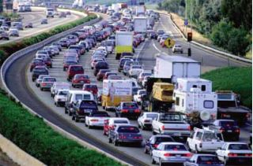

1. Last Sunday an accident caused a traffic jam 12 kilometers long on a four lane highway. How many cars do you think were in the traffic jam?
Explain your thinking and show all your calculations.

Write down any assumptions you make.

2. When the accident was cleared, the cars drove away from the front, one car every two seconds. Estimate how long it took before the last car moved.
Educational Designer November 2009

Challenge level:
Burkhardt, H. “On Strategic Design” 9 Task Exemplars

CHEATING CHAIN LETTER

Max has received this email. It describes a scheme for making money.

From: A Crook
Date: Thursday 15th January 2009
To: B Careful
Subject: $ Get rich quick!$

Dear Friend,

Do you want to get rich quick? Just follow the instructions carefully below and you may never need to work again:

1. At the bottom of this email there are 8 names and addresses. Send $5 to the
name at the top of this list.
2. Delete that name and add your own name and address at the bottom of the list.
3. Send this email to 5 new friends.

Yours Truly,
A Crook

1. If that process goes as planned, how much money would be sent to Max?
2. What could possibly go wrong? Explain your answer clearly.
3. Show as many potential outcomes as you can.
4. Why are chain email scams like this illegal?
Educational Designer Burkardt, H. “On Strategic Design” 22 Task Exemplar
Challenge level:

PLANNING AND ORGANIZING: A PING-PONG LEAGUE

You have the job of organising a ping-pong league.

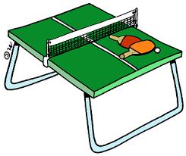

• 7 players will take part
• All matches are singles.
• Every player has to play each of the other players once.
• There are four tables at the club.
• Games will take up to half an hour.
• The first match will start at 1.00pm.

Plan how to organise the league, so that the tournament will take the shortest possible time.

Put all the information on a poster so that the players can easily understand what to do.

https://www.youcubed.org/task/robot-stepper/
Challenge level: (low floor, high ceiling)

Sissa's Reward

According to an old Indian myth, Sissa ben Dahir was a courtier for a king. Sissa worked very hard and invented a game which was played on a board, similar to chess. The king decided to reward Sissa for his dedication and asked what he would like. Sissa thought carefully and then said, "I would like one grain of rice to be put on the first square of my board, two on the second square, four on the third square, eight on the fourth and so on." The king thought this was a silly request, but little did he know ...

Below is a chess board with the first few squares filled with grains of rice as Sissa asked for:
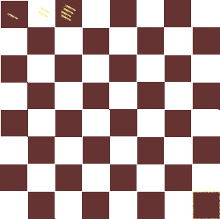
How many grains of rice would there be on the 8th square?
How many grains would you need altogether in order to fill up to the 15th square?
Estimate how many grains you would need in total to fill the entire board in this way. Explain your thinking.
Perhaps Sissa was cleverer than the king thought!

https://nrich.maths.org/7989
Challenge level:
Number, patterns

Sitting Round the Party Table

So, you are at the party and sitting round the table with seven friends.

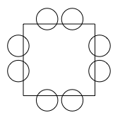
At the top left hand corner is the friend who is giving the party. S/he has a bag of sweets and starts giving them out in a clockwise direction: one for her/himself, two for the next person and three for the next and so on.
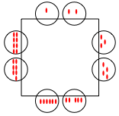
There are other similar parties going on at the same time. They have bigger square tables with more children sitting round on each side.

Explore and compare all the tables: 2 on each side, 3 on each side, 4 on each side and 5 on each side.

You could look at:
the total number of sweets that children sitting opposite each other have;
the total number of sweets needed for each size of table;
the total number of sweets belonging to children who are diagonally opposite.

Then, what about five- and six-sided tables?
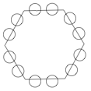

https://nrich.maths.org/5714
challenge level:
Multiplication

Shape Times Shape

The coloured shapes stand for eleven of the numbers from 0 to 12. Each shape is a different number.
Can you work out what they are from the multiplications below?
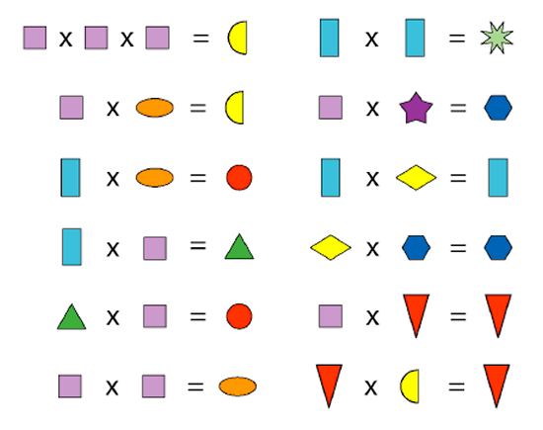

Can you make your own chape code for your someone else to work out?

https://nrich.maths.org/774
Challenge level:
Place Value, code breaking, patterns
Which Scripts?

There are six numbers written in five different scripts.
Can you sort out which is which?
Write 51 in each script.
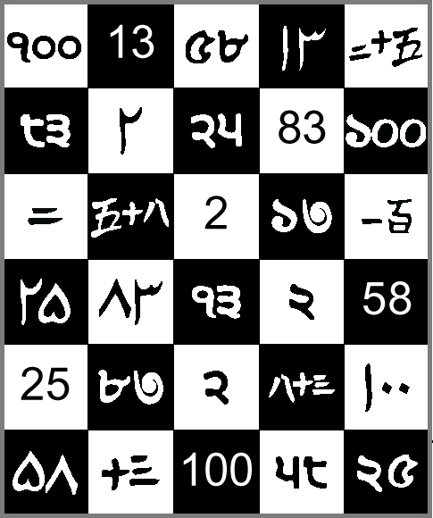
Ext: Make your own script for others to decode.
https://nrich.maths.org/
Challenge level:
Powers of 10, number

The Deca Tree

In the forest there is a Deca Tree.
A Deca Tree has 10 trunks,
and on each trunk there are 10 branches,
and on each branch there are 10 twigs,
and on each twig there are 10 leaves:
One day a woodcutter came along and cut down one trunk from the tree.
Then he cut off one branch from another trunk of the tree.
Then he cut off one twig from another branch.
Finally he pulled one leaf from another twig.
How many leaves were left on the tree then?

http://wild.maths.org/whos-who
Challenge level:
Data Handling

https://nrich.maths.org/9692

Challenge level:
Symmetry (low floor, high ceiling)

http://wild.maths.org/just-one-cut (watch this video to learn more)

Challenge level:
Symmetry

Just One Cut?
Can any shape with straight sides be made by folding a single piece of paper and by making a single complete cut?
Watch the video below to find out more ...
http://wild.maths.org/just-one-cut (watch this video to learn more)
Katie got into this 'fold and cut' problem by trying to cut a square out of a piece of paper as efficiently as possible. Take a look ...

Why don't you have a go at folding a piece of paper and cutting out a triangle with just one straight cut, as Katie suggests?
Can you create a hexagon in the same way?
What other shapes can you create by folding and making just one straight cut?
The Lunch Party Menu

Challenge level:
Math focus:

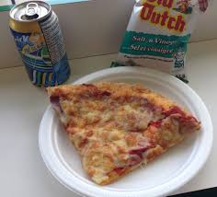
The lunch party menu offers the following category choices:

Food: Veggie pizza or Pepperoni pizza
Drinks: Pop, Water or milk
Snack: Chips, Cookies or fruit

If Olivia chooses one item from each lunch category, select a party lunch for her. How many different party lunch choices could she make?

Extension: The lemonade truck pulls up! If lemonade becomes another drink option, list the new lunch choices that are possible. How many new lunch choices are possible?

Extension #2: If a whole pizza is $12.00 and it is cut into 8 pieces, the drinks are all $1.50 and the snacks are $1.50, what would it cost to feed a whole class of 30 students? If Olivia has $5.00, does she have enough to buy pizza, pop and chips for lunch?
How do you know?

Let's Investigate Triangles
https://nrich.maths.org/93

Vincent and Tara are making triangles with the class construction set. They have a pile of strips of different lengths.
There are:
- yellow strips with 3 holes
- black strips with 4 holes,
- red strips with 5 holes and
- green strips with 6 holes.
There are plenty of strips of each colour.
Vincent makes a triangle with a green strip, a yellow strip and a red strip.
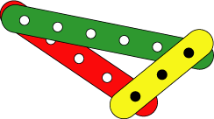
Tara makes a triangle with two green strips and one red strip and another triangle with three black strips.
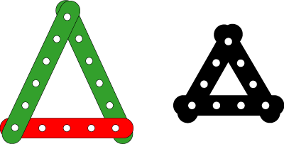
How many different triangles can you make with these lengths?
Can you find three strips which cannot be made into a triangle when you use them together?
Alphabetical Probability
Adapted from Marilyn Burns (http://www.marilynburnsmathblog.com/alphabetical-probability/)
Challenge level:
Math concepts: probability, summarizing and describing distributions, using random sampling to draw inferences, and comparing inferences.

What are the most commonly used letters in the alphabet? How can you be sure?

- Choose a sentence from a book. The sentence should have 10 to 20 words.
- Tally how many times each letter appears in the sentence you chose.
- Record your results.

How many times do you think you might need to repeat this to get a enough data to make conjectures or conclusions?

In what context would it be useful to know this information? (Why might this be helpful to know?)

Are the letters the same in French and English? What might cause any differences you find between the two languages?

Challenge: Once you have determined the most common letters, try to write a sentence without using the top 3 letters. Can you write one without the top 6 most frequently used letters?

Do not share this part with students:
This is the English Letter Frequency according to Cornell University, based on 40,000 words:
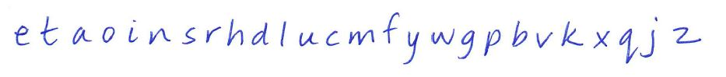

Number Difference

Challenge level:

Math focus: Number sense

Place the numbers from 1 to 9 in the squares below so that the difference between joined squares is odd. (You must use each of the numbers once.)

Can you find some other ways to do this? Explain how you do this.
Can you put the numbers in the squares so that the difference between joined squares is even?
Explain your answer.
What general statements can you make about odd and even numbers?

Biscuit Decorations
Challenge Level:

Math concepts: Divisibility, factors, skip-counting,

Andrew decorated 20 biscuits to take to a party.
He lined them up and put icing on every second biscuit.
Then he put a cherry on every third biscuit.
Then he put a chocolate button on every fourth biscuit.
So there was nothing on the first biscuit.
How many other biscuits had no decoration? Did any biscuits get all three decorations?

Let’s Cut the Cake **
Adapted from Teaching Children Mathematics NCTM May 2016 Volume 23 number 9 pages 542-548

Challenge Level:
Math Focus: 3-D measurement, area and perimeter, equal parts, halving

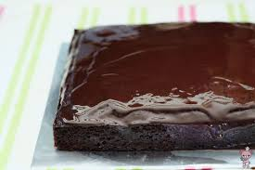
Mateo invited his friends to his birthday party. Mateo and his 2 friends want to share a 9 X 9 square chocolate cake with buttercream frosting. The cake is frosted evenly on the four sides and the top. How can Mateo cut the cake so each person receives an equal share of both cake and frosting? How can you justify that each person got the equal amount of cake and the frosting?

Mateo’s three other friends come to the party right before the cake is cut. How can Mateo cut the cake evenly among 6 people now? How do you know it is fair?

Just as Mateo is about to cut the cake, 3 more friends arrive. How will he cut the cake to make sure everyone at the party gets the same amount of cake and frosting?

**Suggest teachers read the article for ideas of the types of misconceptions students might have. See Leslie for this article.

Alien Numbers

Adapted from Teaching Children Mathematics NCTM April 2018 Volume 24 number 6 pages 348-350

Challenge level:
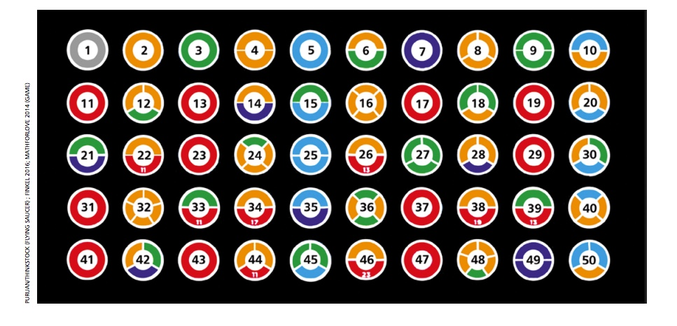
Math Concept: Patterns and Relations, Number sense--prime and composite numbers, constructing an mathematical argument

Top government scientists have discovered part of an alien language, specifically part of their number system. It seems they have a strange way of representing numbers with coloured rings.

The scientists know what the rings look like up to 50, but they cannot yet make sense of them. So, they are publishing what they have found and are asking the public to help crack the code.

What is the meaning of the coloured rings? How can they be extended to numbers beyond 50?
*There is a worksheet that accompanies this problem. Please see Leslie.
How Many Ways?

Adapted from Mathematics Teaching in the Middle School, Vol 23 No. 6 April 2018 pp 310.

Challenge Level:

Math Focus: Combinations and permutations. Making and supporting a mathematical argument

Ms. Johnson is getting a small group of students ready for work. She only allows students to work alone or in groups of 2. She wants to know in how many different ways her students could work in pairs or alone.

When she only has 3 students in her class, there are 4 possibilities:
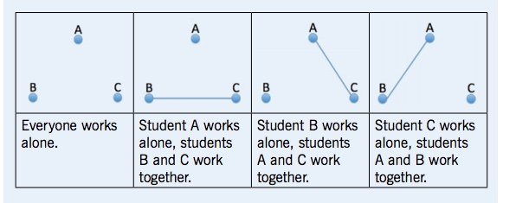

- If Ms. Johnson only allows students to work in pairs or alone, in how many ways could her students be grouped if she has 4 students in her class? Explain how you are sure you have found all the possibilities in each case.
- Ms. Johnson now has a class of 6 students. She found 76 total ways to group her students in groups of 1 or 2. Is she correct? How do you know?

How Many Eggs?

Adapted from Teaching Children Mathematics NCTM Oct 2017 Volume 24 number 2 pages 83

Challenge Level:

Math Focus: Numbers, computation

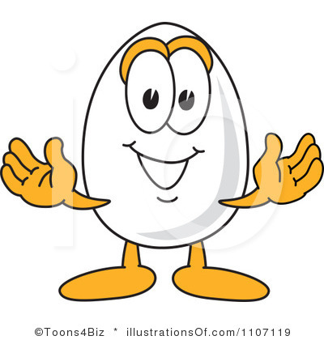
The secret to Mr. Strong’s strength is eggs. The more eggs he eats, the stronger he gets. He eats boiled eggs for breakfast, fried eggs for lunch and fried eggs for supper. If Mr. Strong eats 20 eggs every single day, how many eggs might he have at each meal? How many fried eggs and boiled eggs might he eat in a day?

How many leaves?

Adapted from Teaching Children Mathematics NCTM Oct 2017 Volume 24 number 2 pages 83

Challenge Level:

Math Focus: Numbers, computation

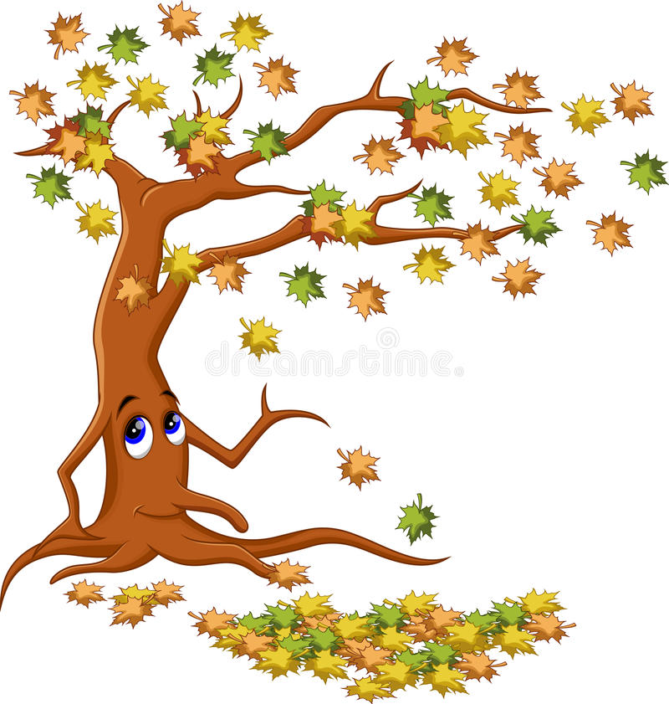

Little Miss Lucky had a dream about the Autumn Tree chasing her across the field. In Little Miss Lucky’s dream, the Autumn tree was losing all its leaves. While she was running away from the tree, Little Miss Lucky counted the red, orange and yellow autumn leaves that were fluttering around in the wind. In total, Little Miss Lucky counted 12 leaves. How many leaves of each colour might she have seen? Show as many possibilities as you can.

Extension: Little Miss Lucky began to count the red, orange and yellow autumn leaves but she also saw some purple leaves fluttering around her. She counted 16 leaves in total. How many leaves of each colour might she have seen? Show as many possibilities as you can.

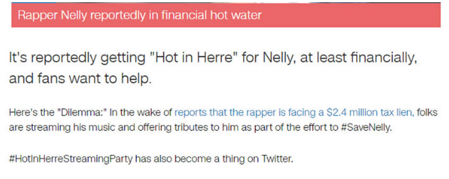
If Nelly is paid between $0.006 and $0.0084 per stream, how many times do Nelly fans have to stream his music for him to pay off his debt?
https://nrich.maths.org/

https://youtu.be/tmlx8Tktg1Q
How many packages of hot dogs and hot dog buns should he purchase so that there are no extra hot dogs or hot dog buns?

This problem provides a context for a real life application of least common multiple (LCM). Students will likely have limited experience with buying hot dogs and hot dog buns, so it would be worthwhile to develop the context prior to showing the video. Questions like the four below will help establish why Steve Martin is so frustrated:
- How many hot dogs come in a package?
- How many hot dog buns come in a package?
- What might happen if you buy one package of hot dogs and one package of hot dog buns?
- How might that make someone feel?
In the movie clip there are 8 hot dogs and 12 hot dog buns in a package.
https://nrich.maths.org/

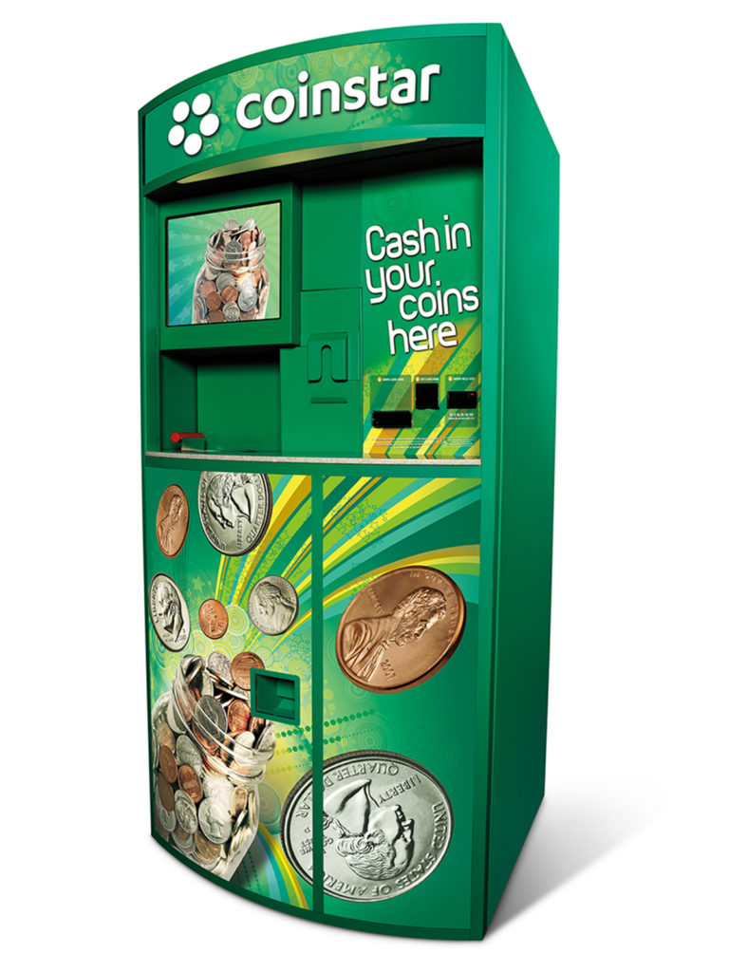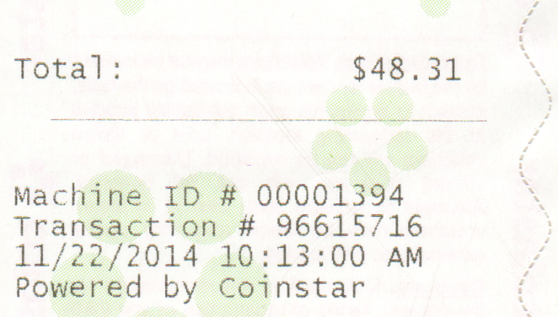
If the total of the receipt is $48.31, what combination of coins were put into the machine?
https://nrich.maths.org/

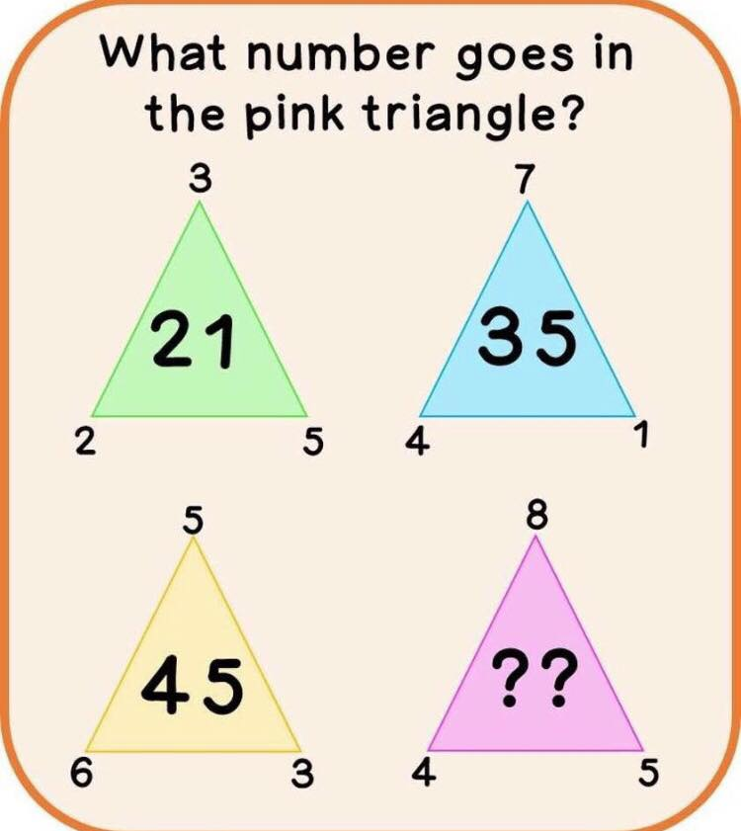
Math Motivator Facebook

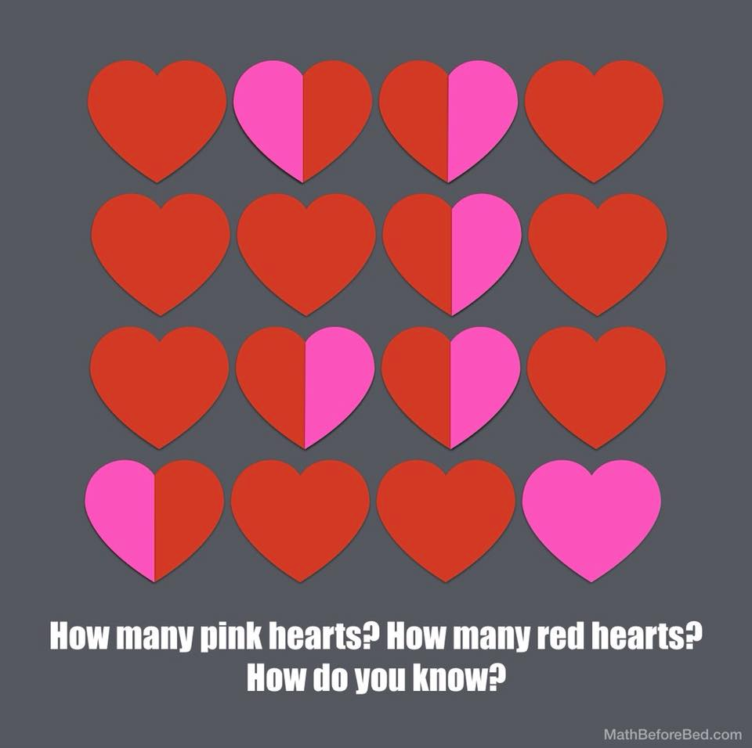

Mr. Silly’s Nonsense Land

Adapted from Teaching Children Mathematics NCTM Oct 2017 Volume 24 number 2 pages 83

Challenge Level:

Math Focus: Numbers, computation

Mr. Silly lives in Nonsense Land, a place where even dogs where hats. One sunny day, Mr. Silly went for a walk to the park. When he arrived, a group of dogs was throwing balls and the dog’s owners were fetching them. All the dogs and owners were wearing hats, of course. In total, Mr. Silly saw 7 hats and 20 legs. How many dogs and how many people did Mr. Silly see?

Extension: Later in the day, even more dogs and owners arrived in Nonsense Land Park. In total, 13 hats and 40 legs were in the park. How many dogs and how many people were in the park now?

3 Block Towers

This task can be found at: https://nrich.maths.org/7196

Challenge Level:

Math Focus: Patterns and Relations, Shapes and Space
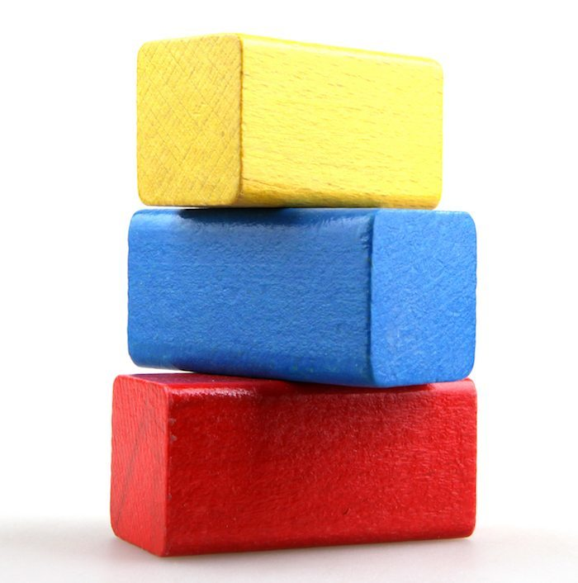
How many different towers can you make using one blue block, one red block and one yellow block?

Extension: How many towers can you make if you have a green block as well?

The Game of NIM

This task can be found at: https://nrich.maths.org/1204

Challenge Level:

Math Focus: Number Sense, Patterns and Relations
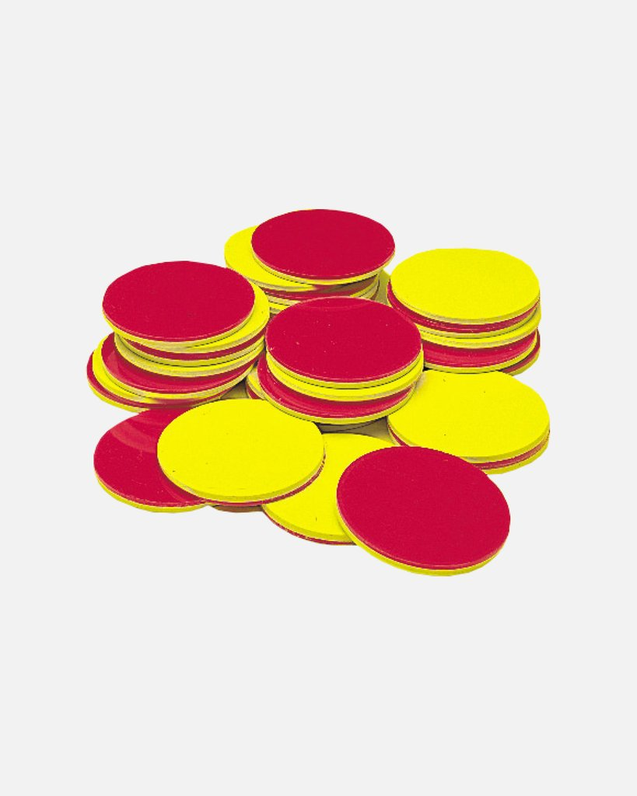
Find a partner. Place 7 counters in a group and decide who will go first. Each player takes a turn and removes 2 or 1 counters. The player that goes last, loses. Does it matter who goes first? Keep playing until you find a way for both players to win.

Extension: Try playing with 8 counters. What do you notice? Try playing with 9 counters. What do you notice?

Ivan, Grandma and the Acrobats Tug of War
Adapted from Marilyn Burns
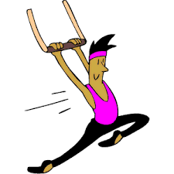
Game 1: The 4 acrobats have a tug of war with the 5 grandmas. It is a draw.
Game 2: Ivan, the dog, goes up against 2 grandmas and an acrobat. It is a draw.
Game 3: 3 grandmas and Ivan are locked in battle with 4 acrobats. Who will win this game?

Extension: Are there any other combination of Tug of War that will end in a draw?

Can You Solve the Bridge Problem?

https://www.youtube.com/watch?v=7yDmGnA8Hw0&feature=youtu.be
This is a YouTube video from Ted-Ed. The problem is the first few minutes of the video. This is followed by the solution (Don’t show them this just yet...they need to figure it out!)

Can You Solve the Prisoner Hat Problem?
https://www.youtube.com/watch?v=N5vJSNXPEwA
This is a YouTube video from Ted-Ed. The problem is the first few minutes of the video. This is followed by the solution (Don’t show them this just yet...they need to figure it out!)

